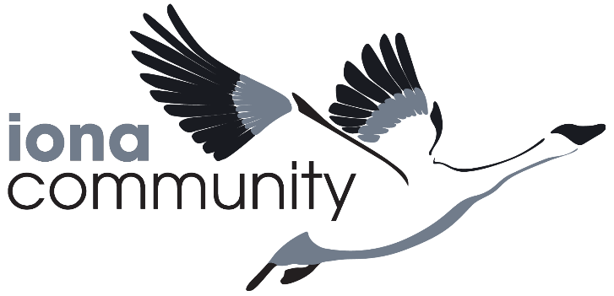
Iona Community Associates
Enrollment/Renewal Form

I (we) ____________________________________ hereby enroll/renew as an Associate of the Iona Community and make my (our) commitment to the Rule of Associates of the Iona Community in token where of I (we) enclose my (our) annual donation.

Amount Enclosed:
Individual: $100______
Couple: $150 _______
Senior Citizen or Student: $ 30 _ __________________

Please make payment to: “The Iona Community New World Foundation” and return to

Iona Community – New World Foundation
C/O Kirkridge Retreat and Study Center
2495 Fox Gap Rd,
Bangor, PA 18013.

Please provide the following contact information below:

Name:_____________________________________

Address:__________________________________________

City, State and Zip Code: _ ____________________________

Phone:__________________________________

E-mail:_________________________

The Iona Community is an ecumenical Christian movement seeking new ways of living the gospel in today’s world through working for peace and social justice rebuilding community and in the renewal of worship.
Per IRS regulations, your gift is fully tax deductible. No goods or services have been provided in whole or in part for your contribution.

